System Test Cases

Contents

Overview 1

1. System Initialization 1

2. Manager: Create Trainer 4

3. Manager: Modify Trainer Data 11

4. Recover Username 15

5. Reset Password 16

6. Manager: Create Customer 18

7. Manager: Modify Customer Data 20

8. Manager: Create Equipment 23

9. Manager: Modify Equipment 25

10. Trainer: Create Exercise 28

11. Trainer: Modify Exercise 30

12. Trainer: Create Routine 32

13. Trainer: Modify Routine 33

14. Trainer: Assign Routine 35

# Overview

This document gives the steps that the customer can use to validate the system’s functionality. Tests should be performed in order.

# 1. System Initialization

1. With no stored system data, run the Skynet Gym program

* Input: None
* Output: System displays Create Manager Account Page

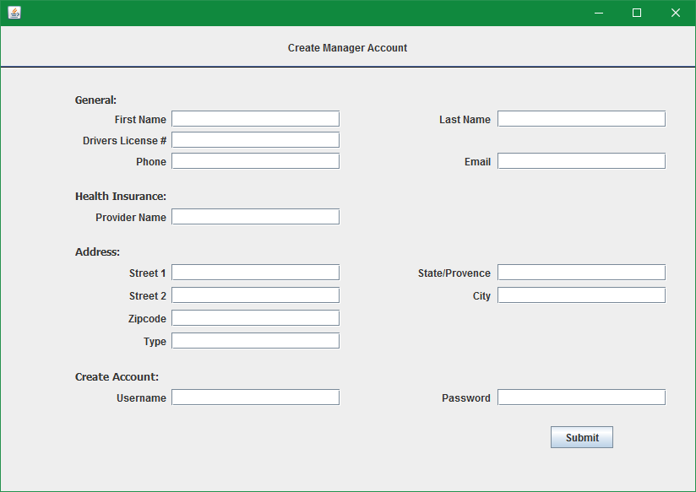

1. If any fields are blank, the system should notify you that there are empty fields upon submission. Test this functionality by clicking submit.

* Input: Click submit button
* Output: Error that fields are empty

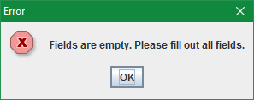

1. Assuming the role of the manager, enter the following information in the form and click submit

* Input:
  + Password: "pw"

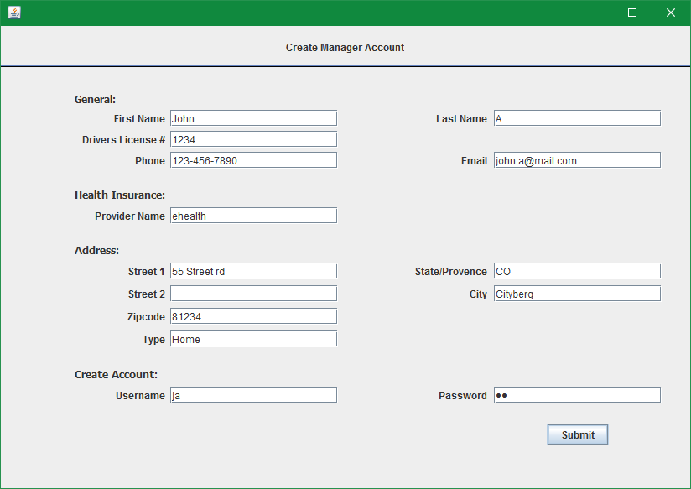

* + Click Submit
* Output: Manager Screen

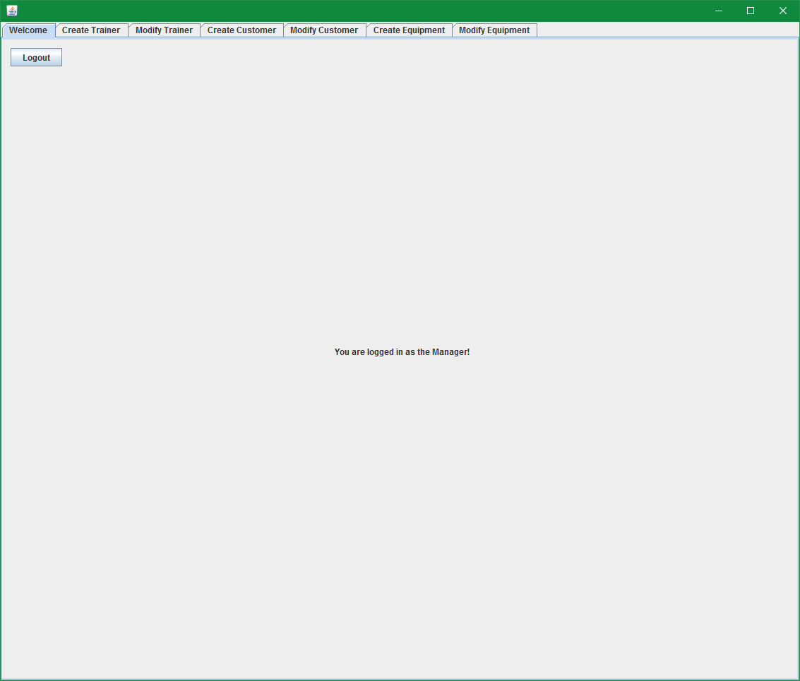

1. Validate that the manager account was saved by closing the program

* Input: Click the close window X
* Output: Program is closed

1. Reopen Skynet Gym and you should get the login screen

* Input: None
* Output: Login screen

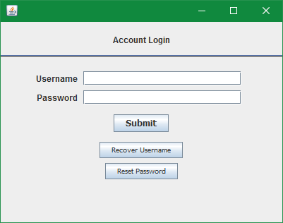

1. Validate that the provided manager username and password allow you to login successfully

* Input:
  + Username: ja
  + Password: pw
  + Click submit
* Output: Manager Screen



# 2. Manager: Create Trainer

1. From the Manager Screen, select the Create Trainer Tab

* Input: None
* Output: Create Trainer Tab

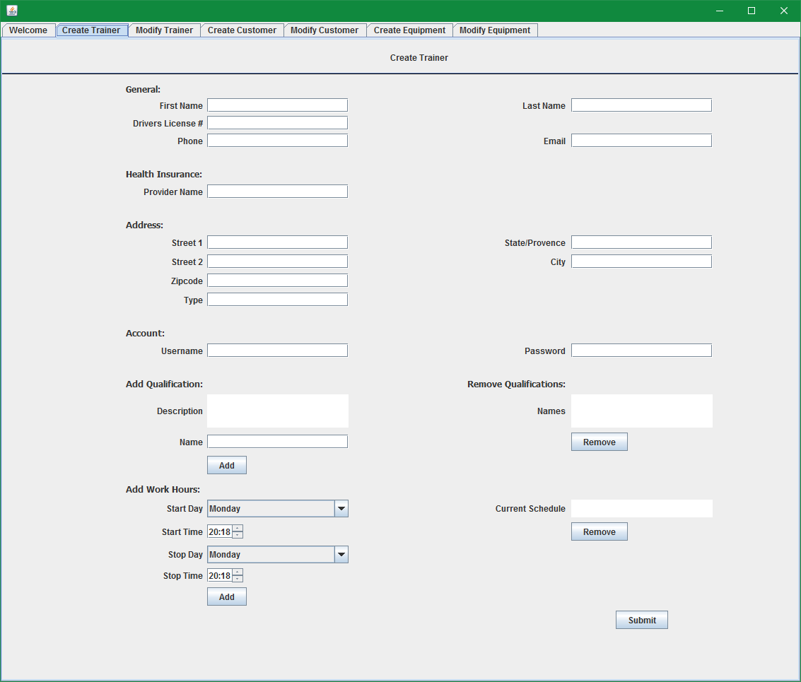

1. If any fields are blank, the system should notify you that there are empty fields upon submission. Test this functionality by clicking submit.

* Input: Click submit button
* Output: Error that fields are empty



1. Validate that work hours entered must be valid periods of time that do not span more than one day.

* Input:

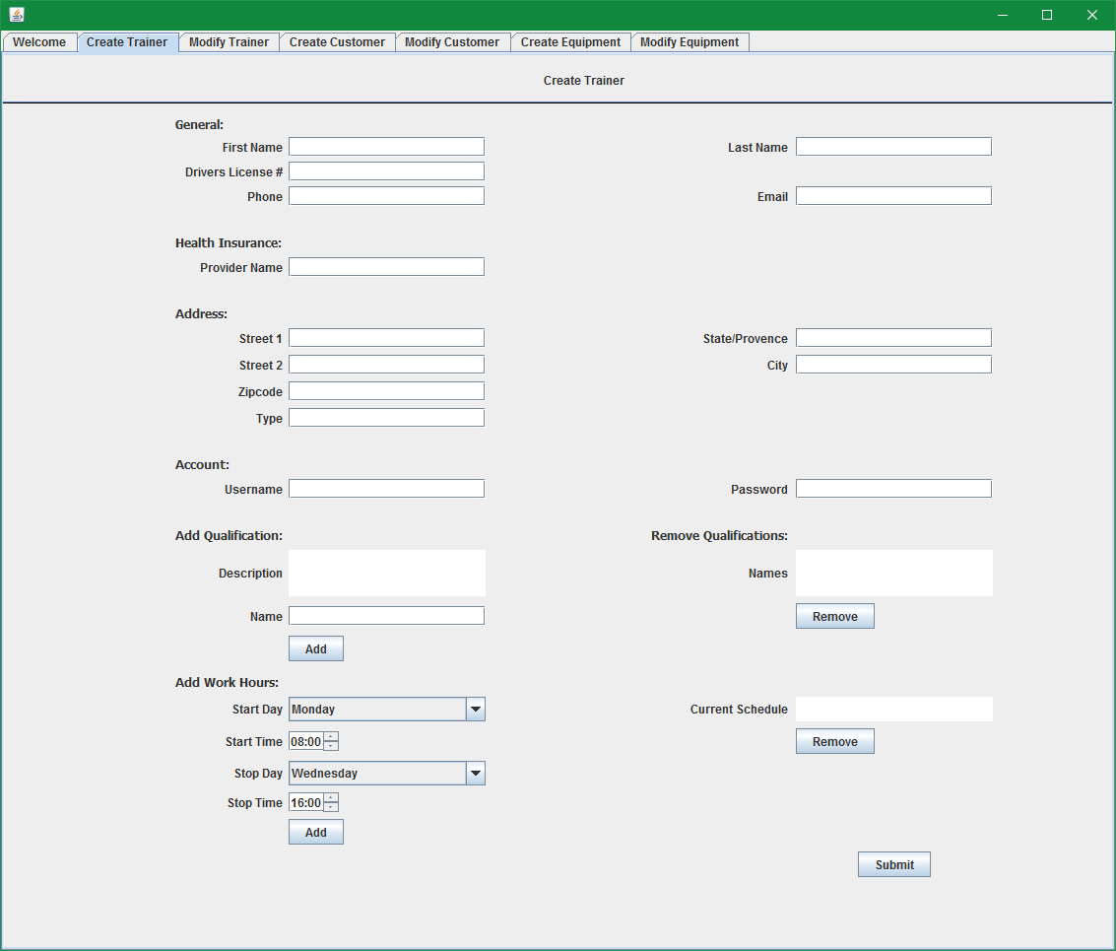

* + Click the Add button in the "Add work Hours Section"
* Output:

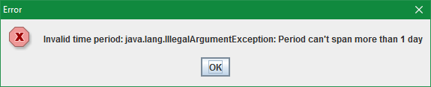

1. If the entered Drivers license number or username correspond to an existing user then submission should fail. Try using the same drivers license number as the manager account.

* Input:
  + Fill out the form as follows:
  + Password: "pw"

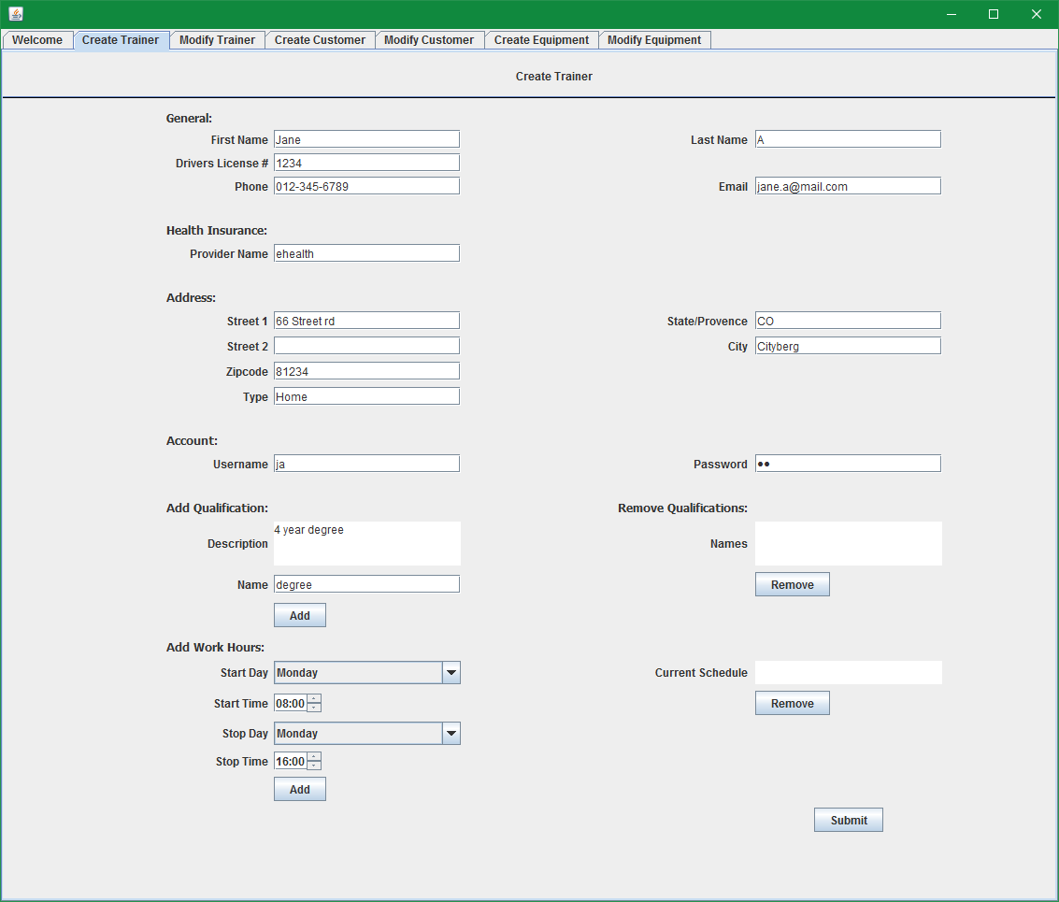

* + Click the Add button in the Add Qualification section
  + Click the Add button in the Add Work Hours section
  + Click Submit
* Output:

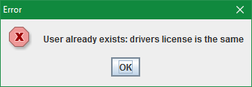

1. Change the drivers license information and validate that there is a check that the username is unique.

* Input:

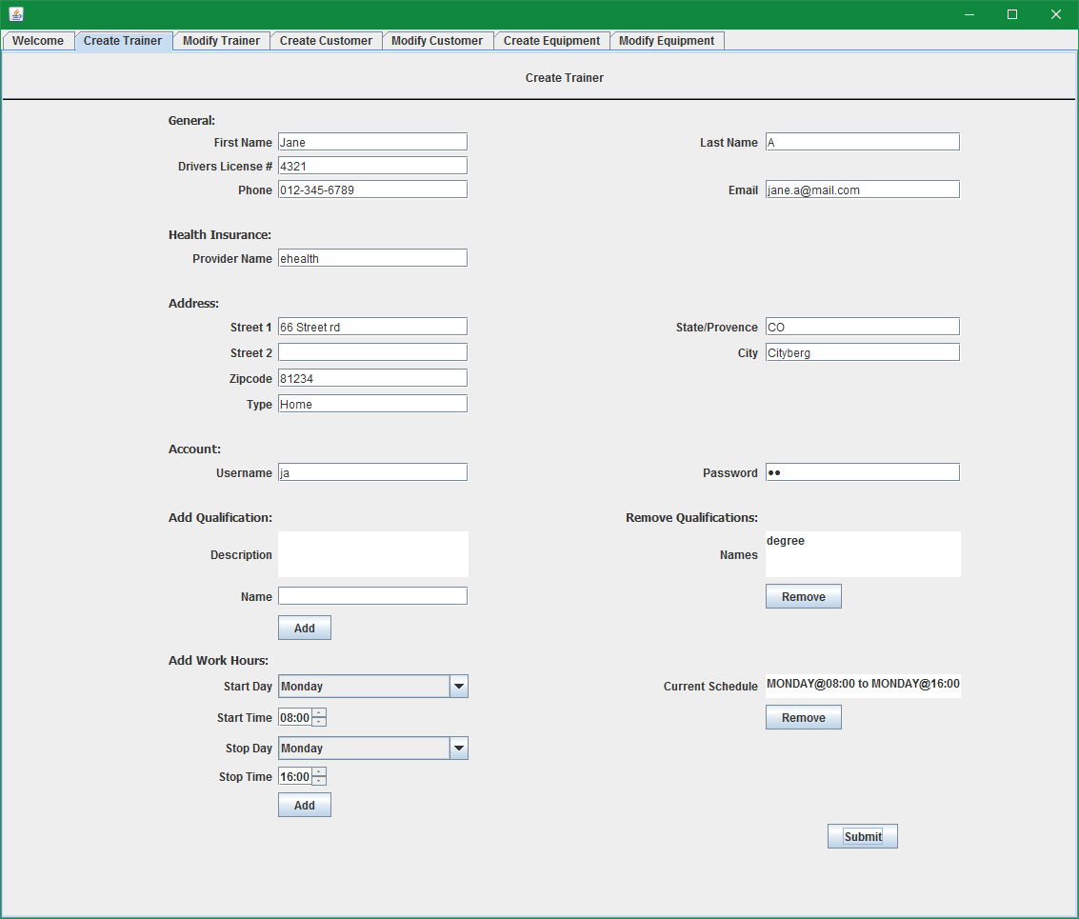

* + Click Submit
* Output:

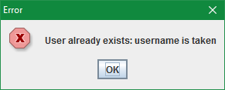

1. Change the username to be unique and the account creation should succeed.

* Input:

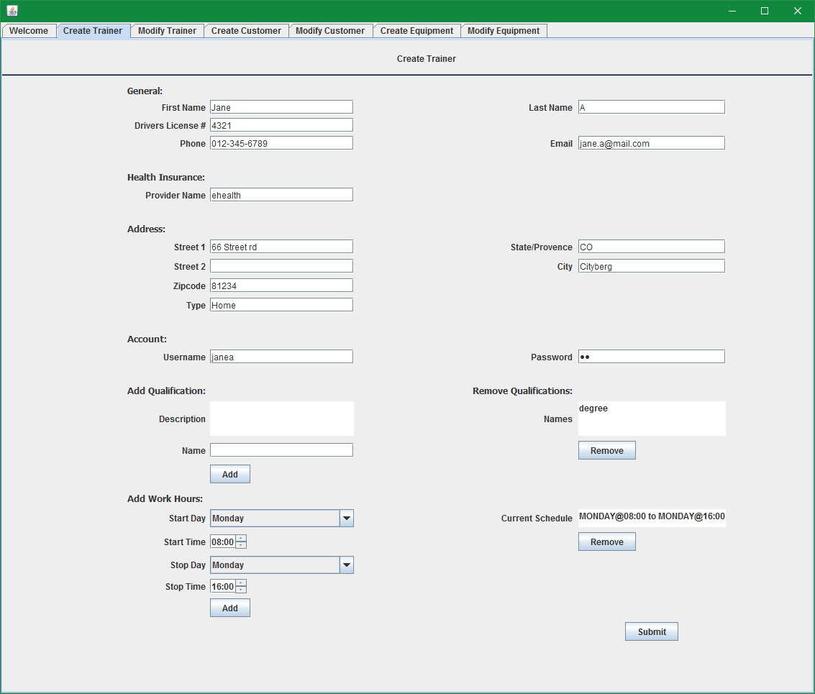

* + Click Submit
* Output:

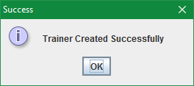

1. Clicking ok on the Success window will dismiss the pop up and clear the Create Trainer form.

* Input:
  + Click ok
* Output:

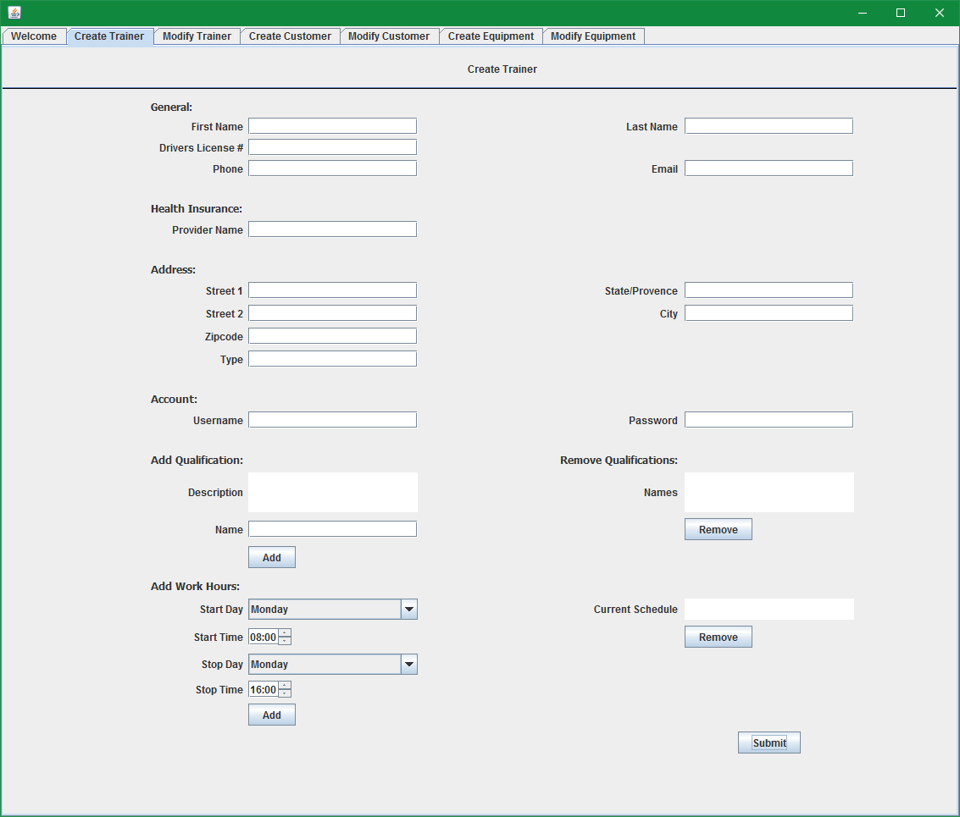

1. Reopen Skynet Gym and you should get the login screen

* Input: None
* Output: Login screen



1. Validate that the new trainer account username and password allows you to login successfully

* Input:
  + Username: janea
  + Password: pw
  + Click submit
* Output: Trainer Screen

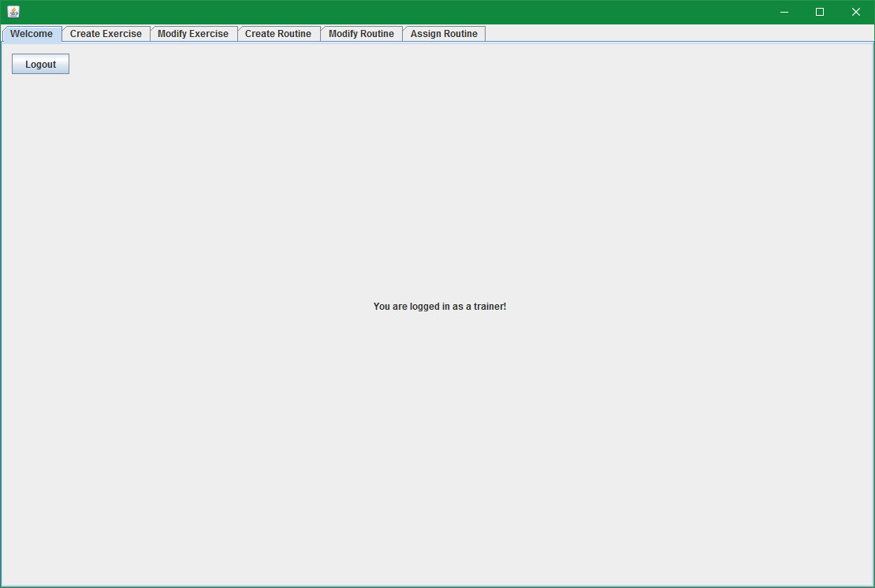

# 3. Manager: Modify Trainer Data

1. Log in as the manager (username: ja, password: pw)
2. Select the Modify Trainer Tab

* Input: None
* Output: You should be presented with a form to select a trainer to modify

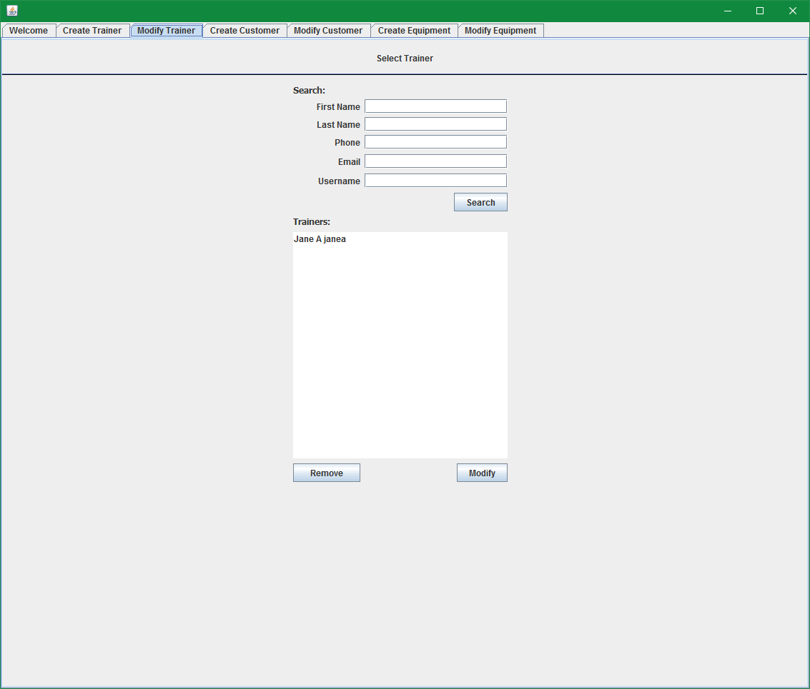

1. Validate that clicking the modify button without selecting a trainer does not do anything

* Input: Click modify button
* Output: No change to UI

1. Select a trainer to modify

* Input: Click on "Jane A" in the list and then click Modify

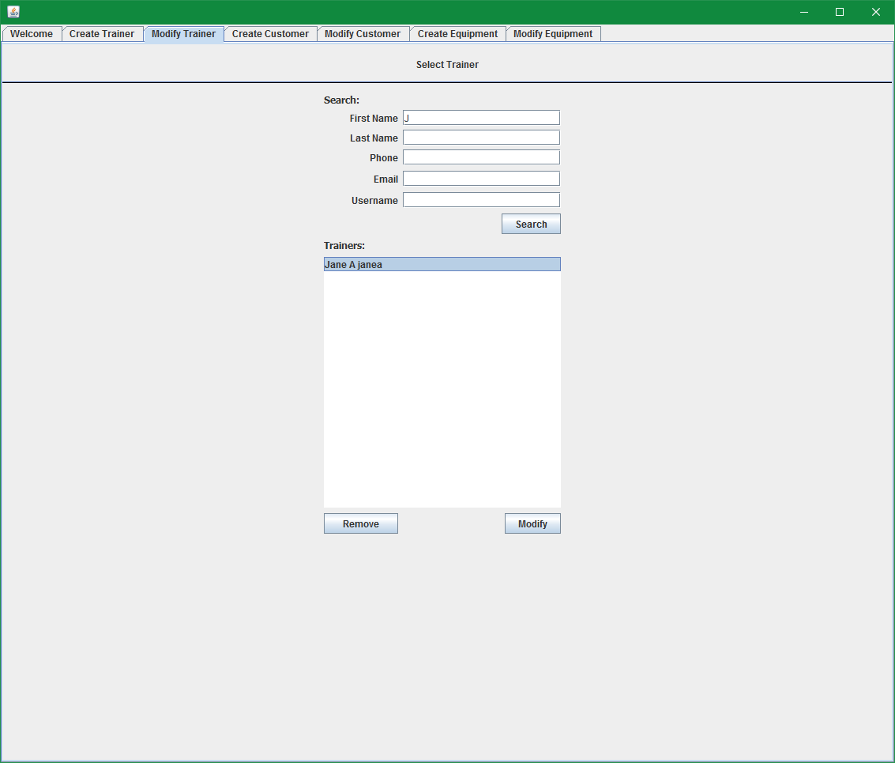

* Output: New tab is created for modifying the trainer

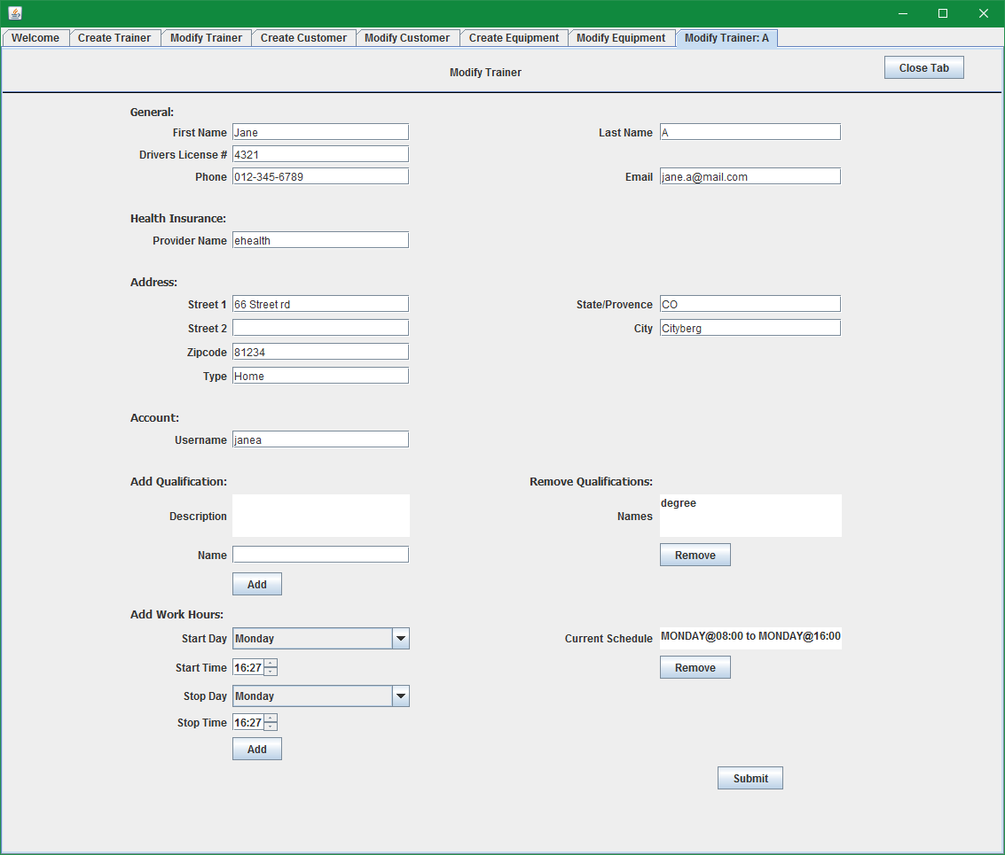

1. Modify and submit the change

* Input: Change the Last name to "Doe", email to "jane.d@mailo.com", username to "janed", then click submit

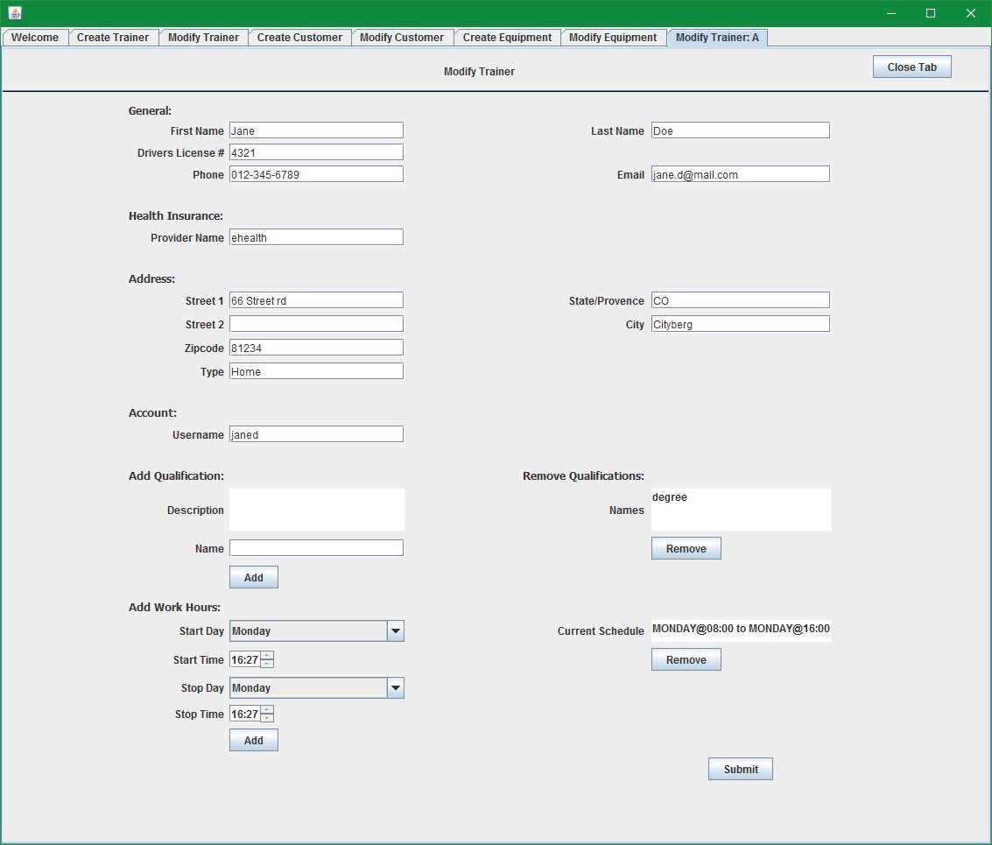

* Output: Success confirmation

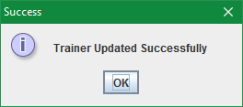

1. Close the Skynet Gym program and reopen it

* Input: Click the Welcome tab and click logout
* Output: Login screen

1. On the login screen, enter the new username and password of the new trainer

* Input: username: "janed", password: "pw"
* Output: Login success



1. Validate that login succeeds and that you are given the trainer screen

* Input: Click modify button
* Output: No change to UI

# 4. Recover Username

1. With an initialized system, run the Skynet Gym program

* Input: Run program
* Output: Login screen

1. Select the “Recover Username” button

* Input: click "Recover Username"



* Output: Recover Username screen

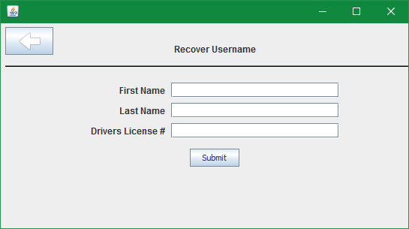

1. You should see a form with fields for First name, Last name, and Drivers license number

* Input: Fill out with the manager information, click submit

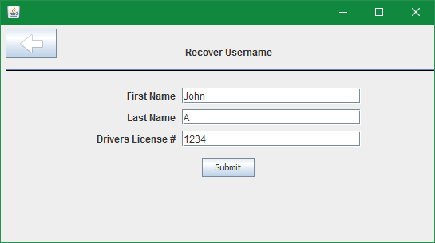

* Output: Popup with username

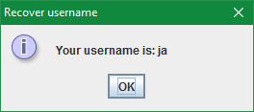

# 5. Reset Password

1. With an initialized system, run the Skynet Gym program

* Input: Run program
* Output: Login screen

1. Select the “Reset Password” button

* Input: click "Reset Password"



* Output: Reset Password screen

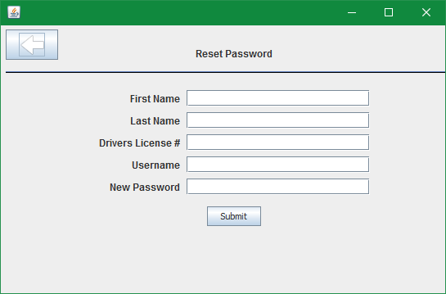

1. Fill out the form

* Input: Fill with Manager information and set the new password to "mypw"

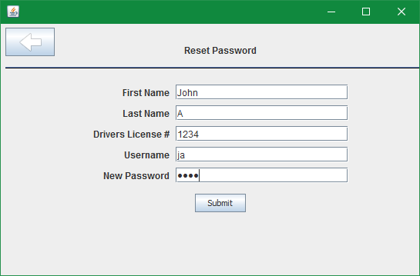

* Output: Success message, followed by return to login screen

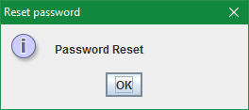

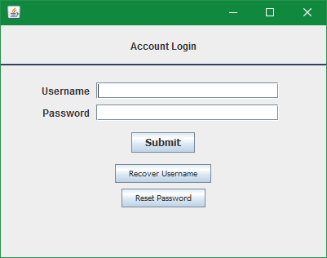

1. Try new password

* Input: username: "ja", password: "mypw"

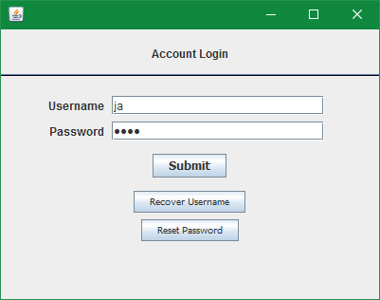

* Output: Logged in as manager



# 6. Manager: Create Customer

1. Log in as the manager and select the Create Customer Tab

* Input: Select Create Customer
* Output: Create customer tab

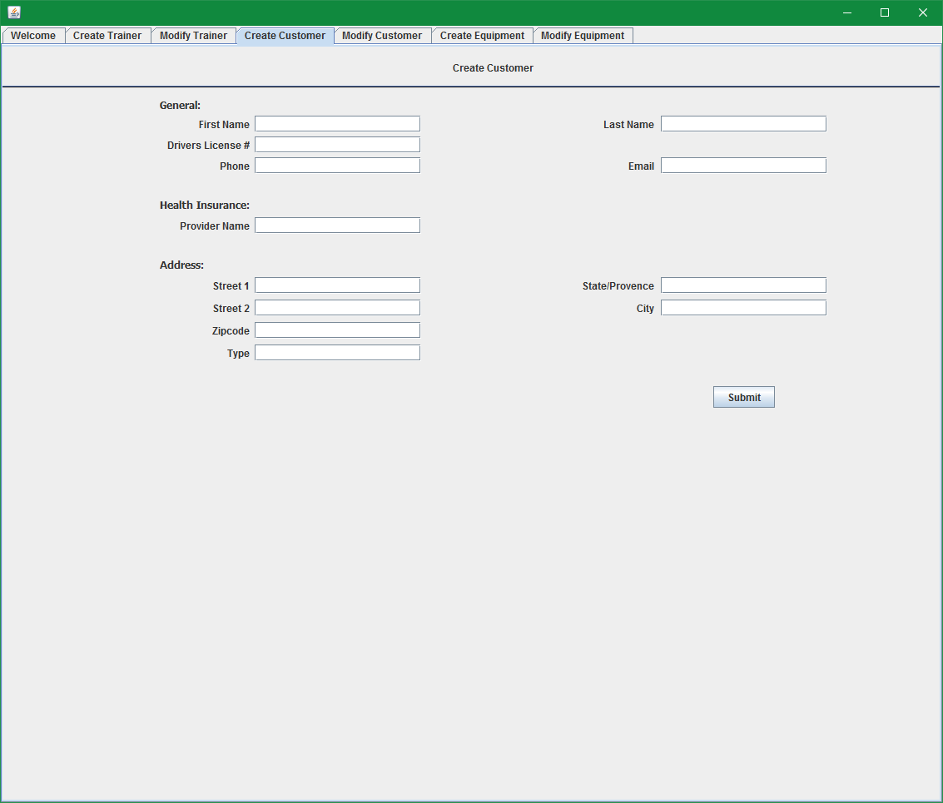

1. Empty fields should result in a failure message

* Input: Select Submit
* Output:



1. Fill out the form with valid information and submission should be successful

* Input: Fill out form as follows and click submit

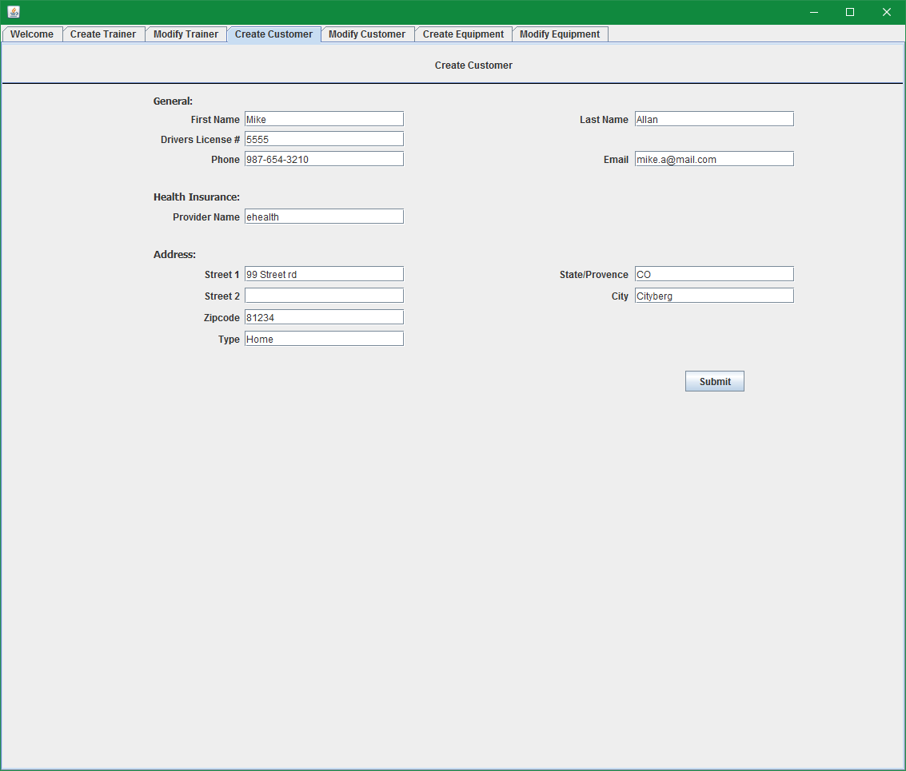

* Output:

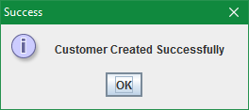

# 7. Manager: Modify Customer Data

1. Log in as the manager and select the Modify Customer Tab

* Input: None
* Output:

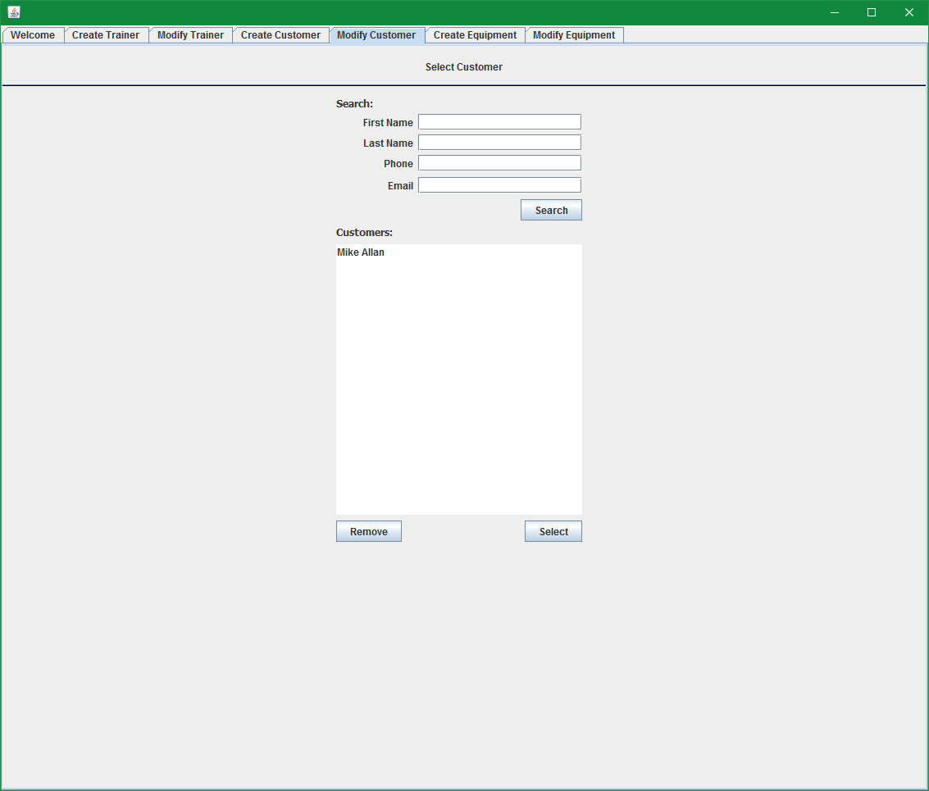

1. Select a customer in the list and click the Modify button

* Input: select Mike Allan in the list and click Select

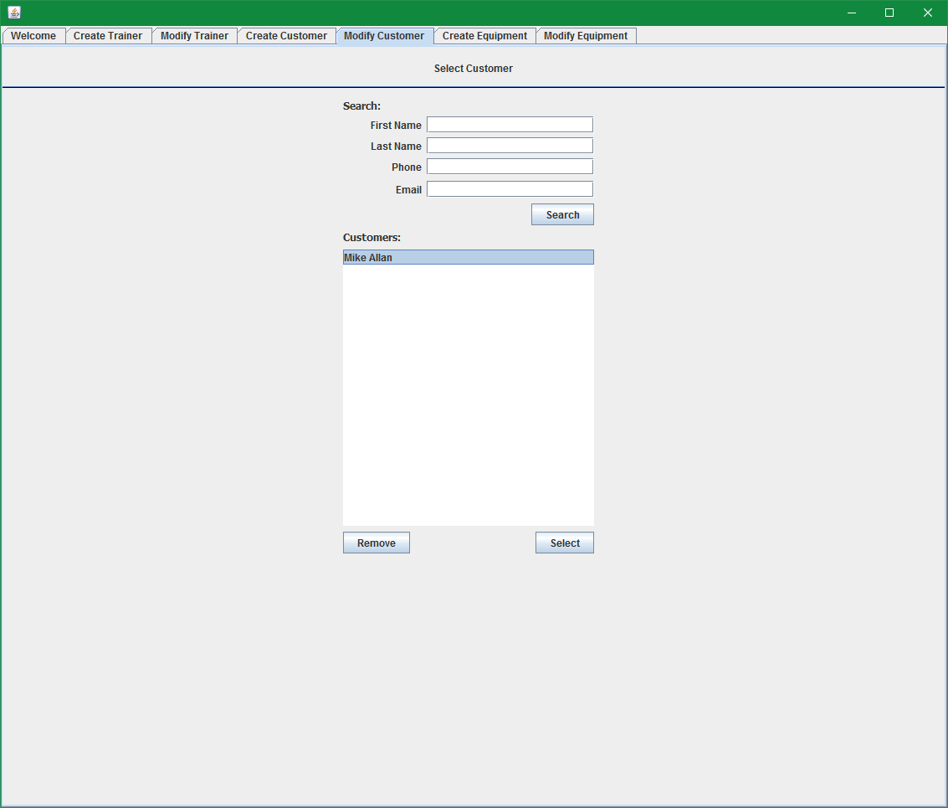

* Output: Modify customer tab populated with customer data

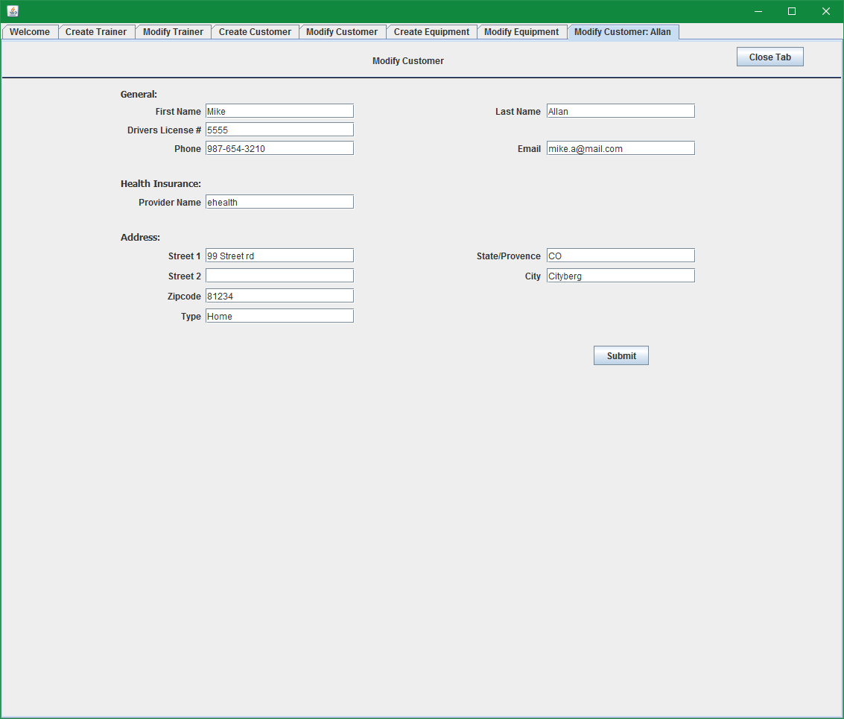

1. Modify a field to test making a change

* Input: set Provider Name to: "ehealth usa" and click submit

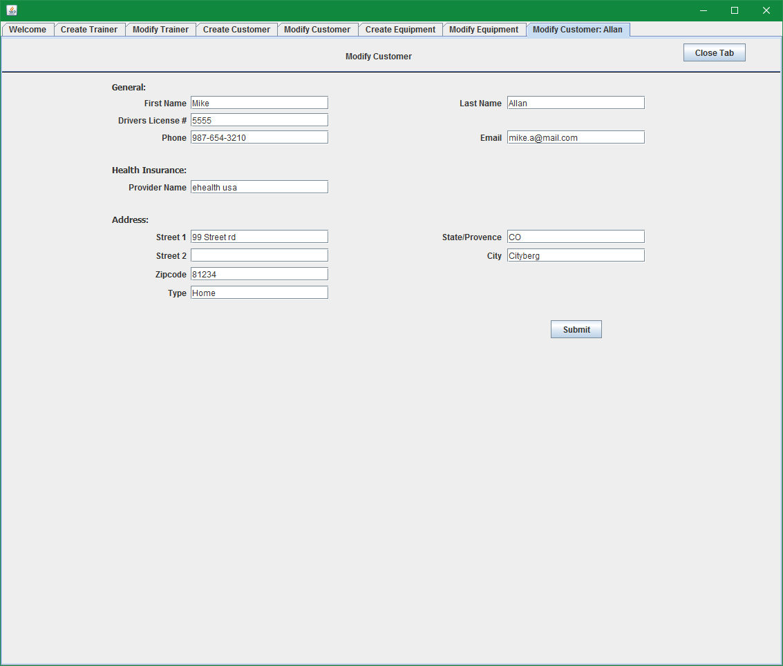

* + Output:

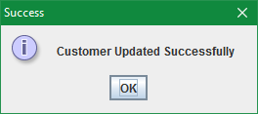

1. To validate that the information has been updated, you can repeat the steps to select the customer and the form should come up again with the newly updated information

# 8. Manager: Create Equipment

1. Log in as the manager, select the Create Equipment Tab
   * Input: None
   * Output:

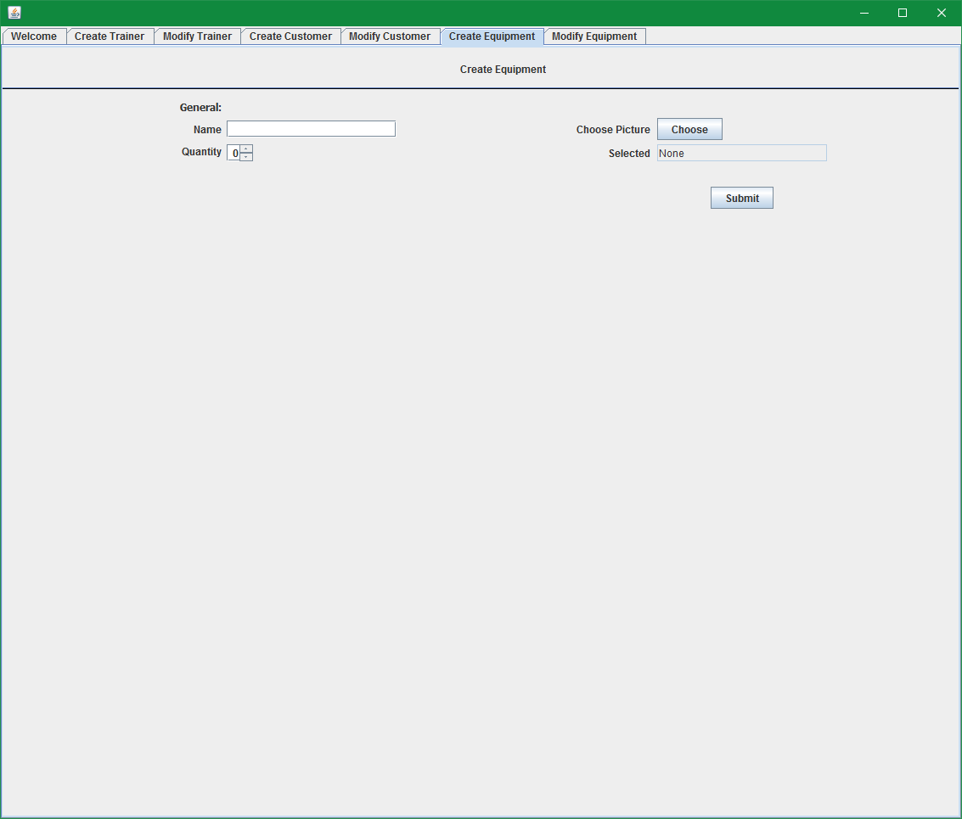

1. Fill out the form with valid information and submission should be successful
   * Input: Fill out the name and quantity as shown below, Choose a jpg picture from your computer, select Submit

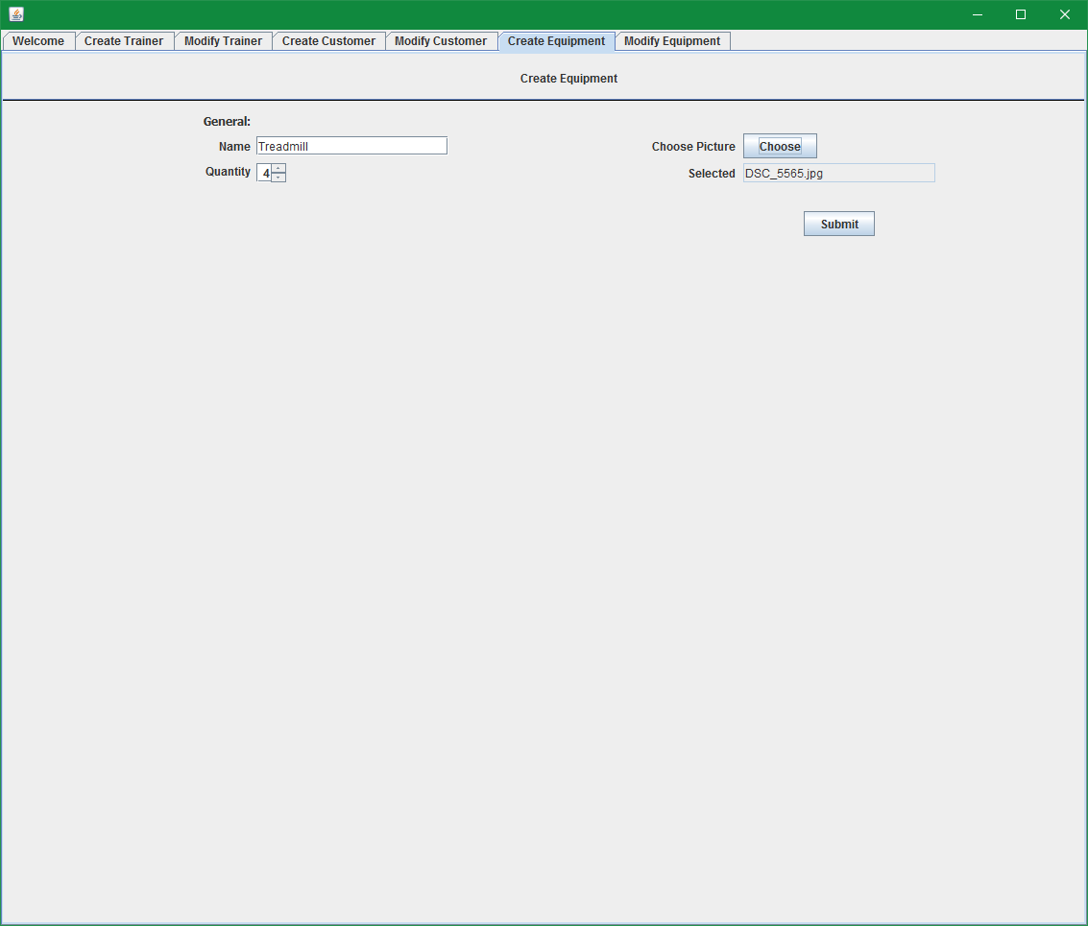

* + Output:

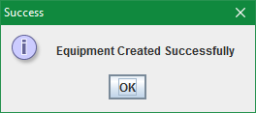

# 9. Manager: Modify Equipment

1. Log in as the manager, select the Modify Equipment Tab
   * Input: None
   * Output:

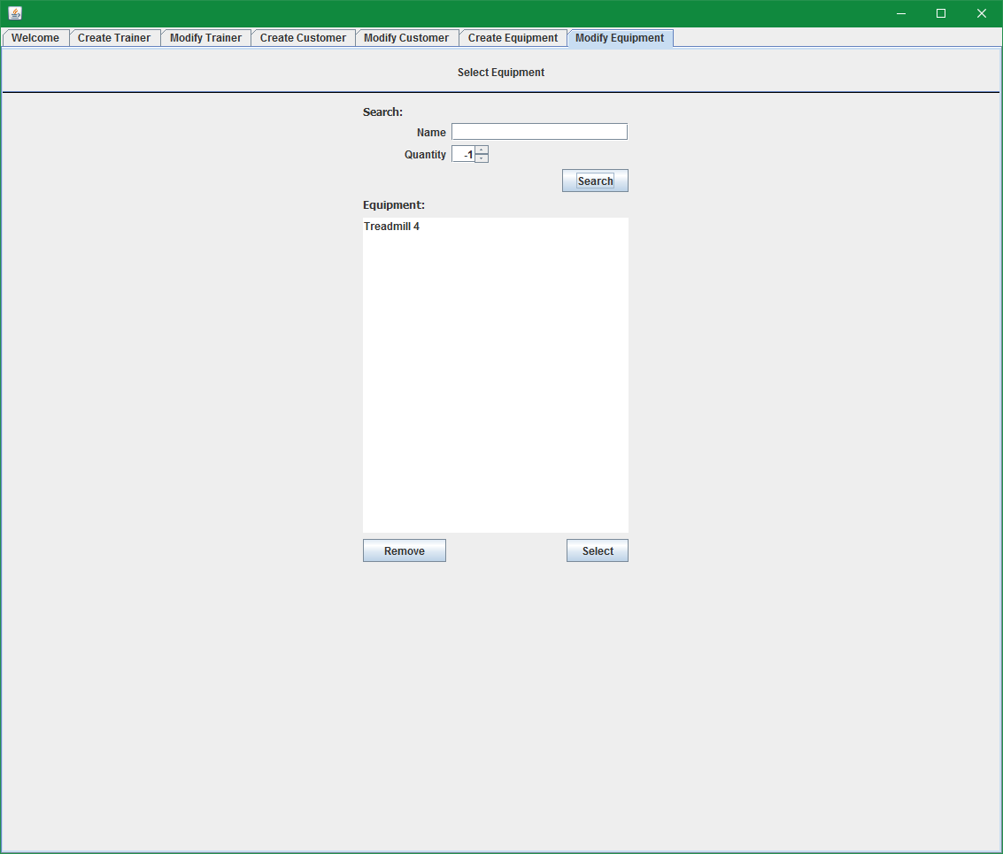

1. Select an equipment entry in the list and click the Select button

* Input: Select "Treadmill 4", and click Select

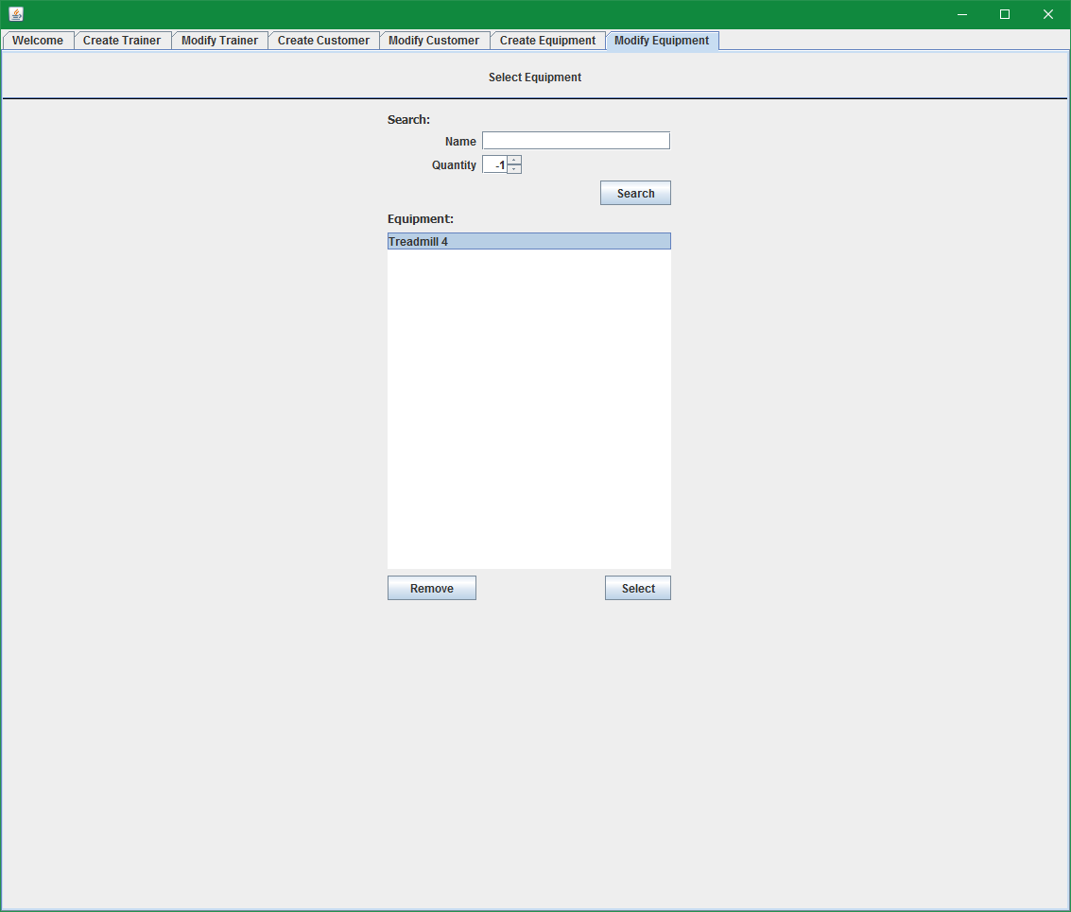

* Output: Modify equipment tab with Treadmill data populated

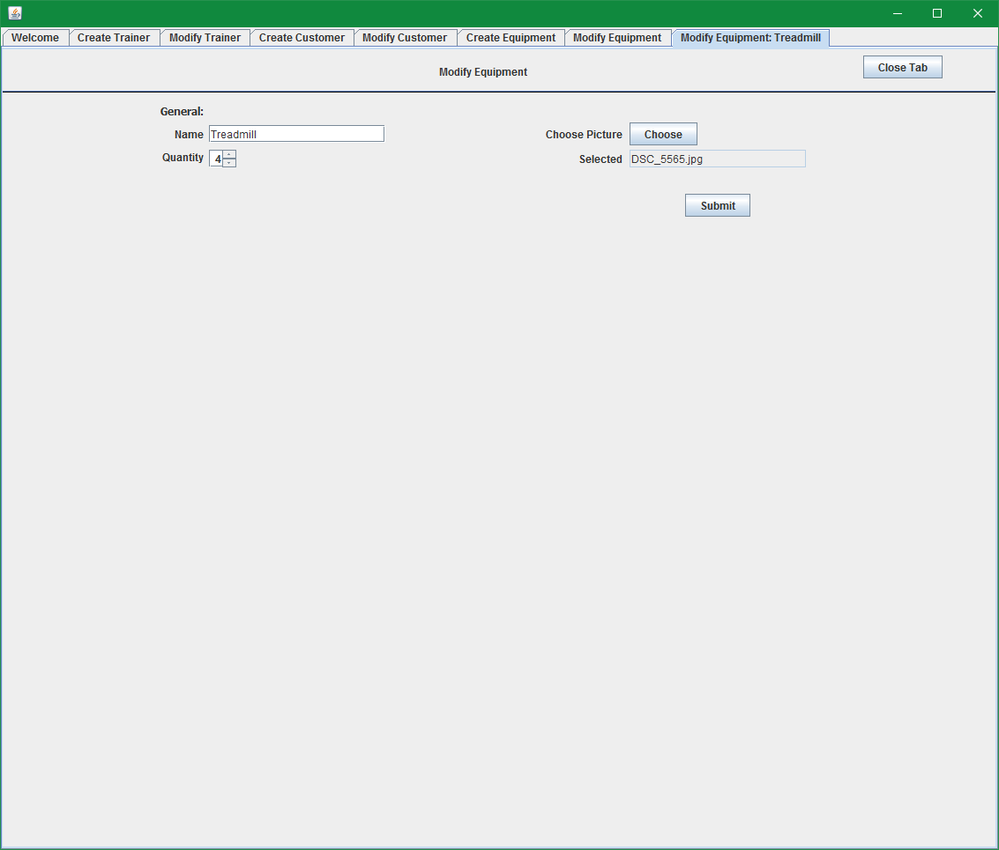

1. Modify the quantity to test making a change

* Input: Change Quantity to 5, and click submit

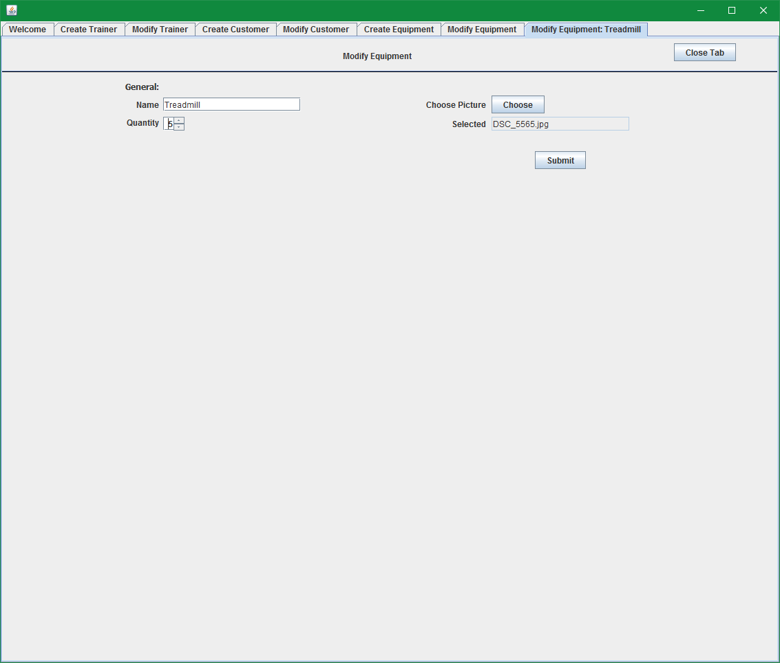

* Output:

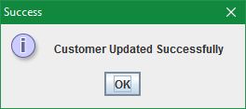

1. To validate that the information has been updated, you can close the tab, repeat the steps to select the equipment and the form should come up again with the newly updated information

# 10. Trainer: Create Exercise

1. Log in as a trainer (username: janed, password: pw), select the Create Exercise Tab

* Input: Login and select create exercise
* Output:

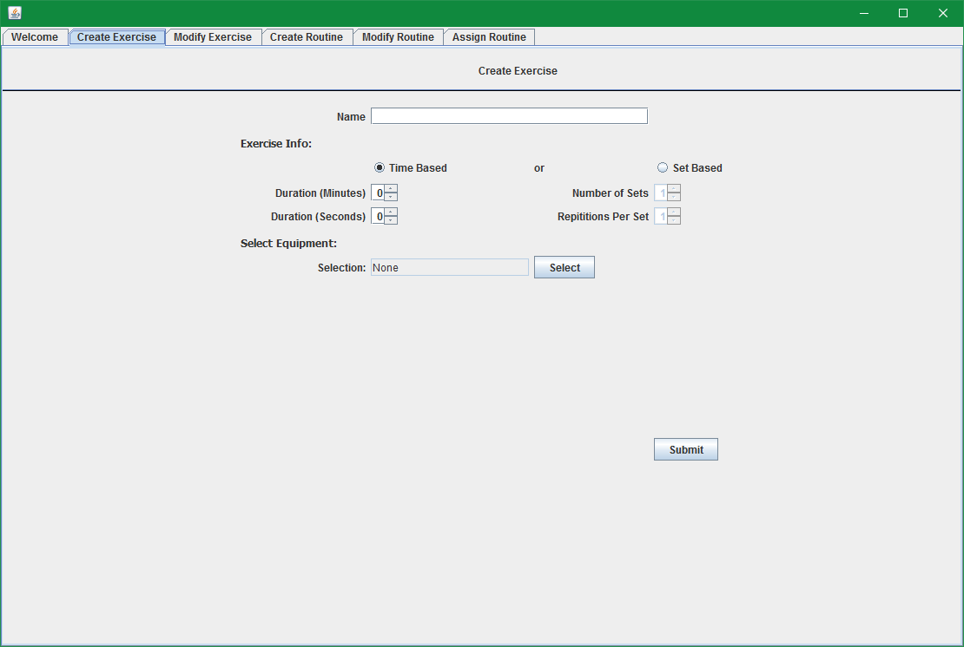

1. Fill out the form as follows to create a time based exercise

* Input: name is "Running", duration is 10 minutes, and select the Treadmill equipment. Click submit

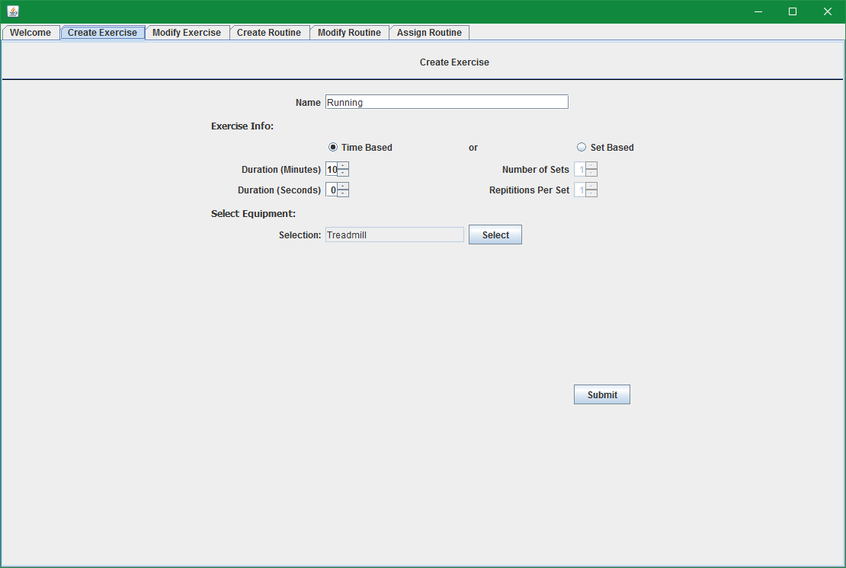

* Output:

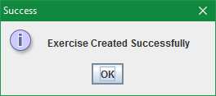

1. Fill out the form again to create a set based exercise

* Input: name is "Pushups", click "set based", 4 sets, 10 reps, no equipment. click submit

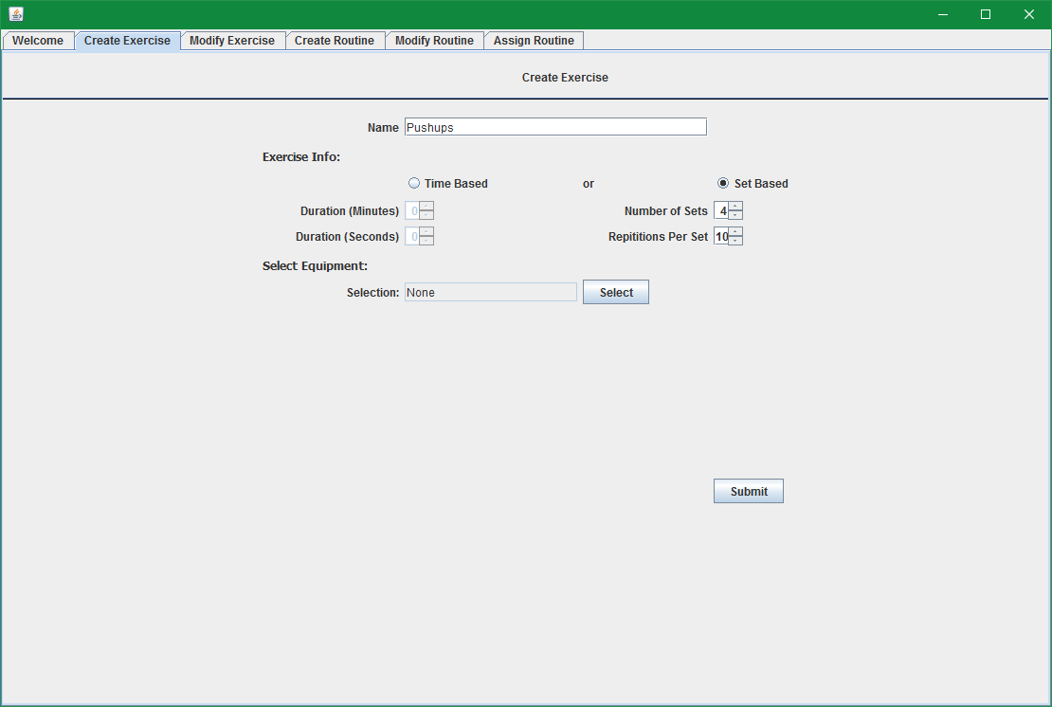

* Output:



# 11. Trainer: Modify Exercise

1. Log in as a Trainer (username: janed, password: pw), select the Modify Exercise Tab

* Input: Select modify exercise
* Output:

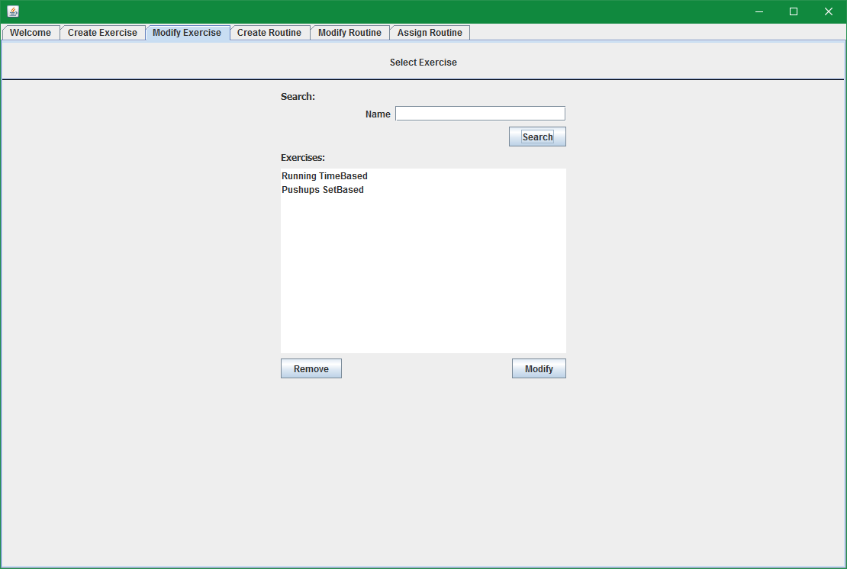

1. Select an exercise in the list and click the Modify button

* Input: Select Running exercise and click modify

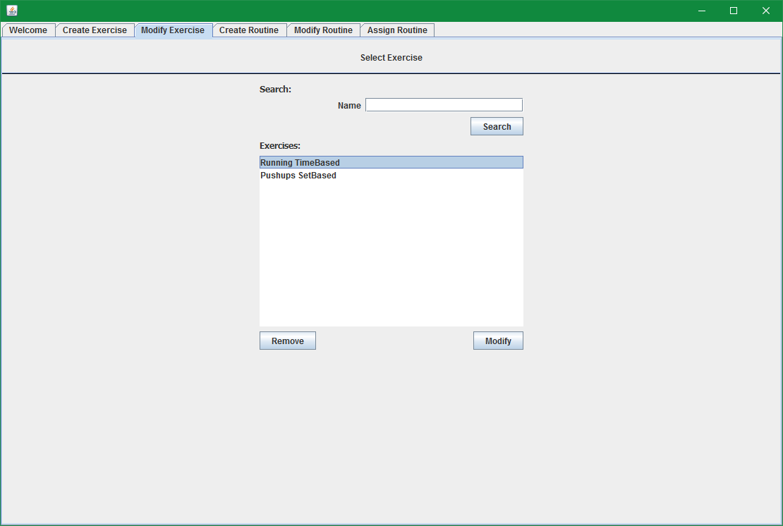

* Output: Shows exercise information populated

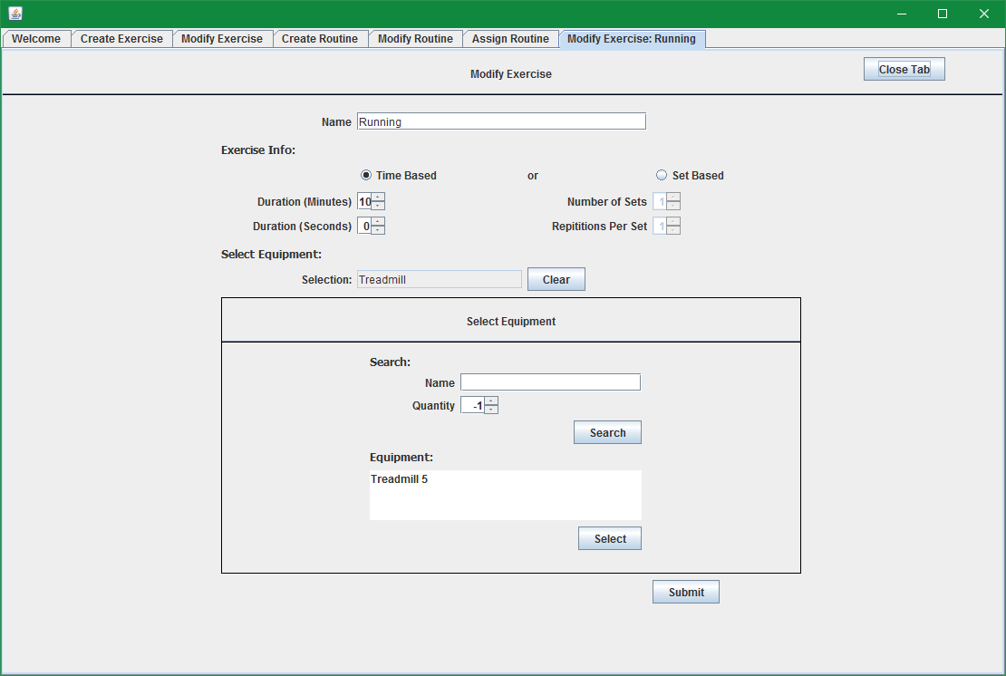

1. Change duration to 15 minutes

* Input: change duration to 15 minutes and click submit

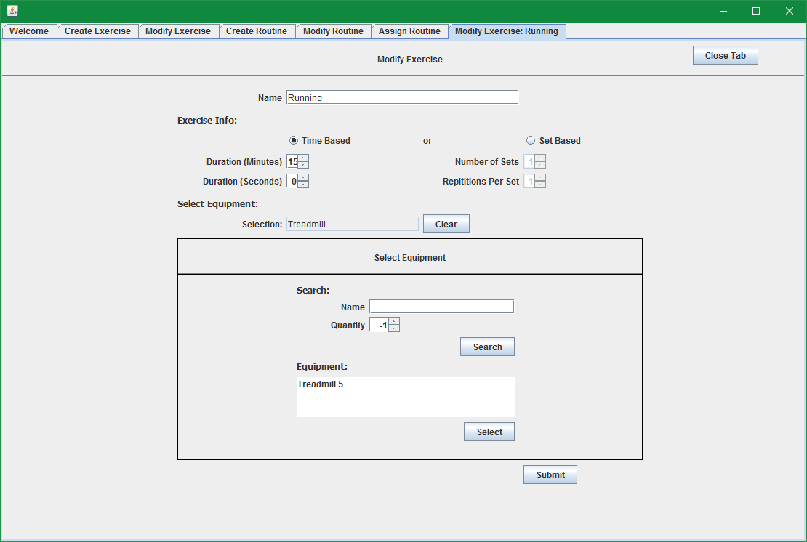

* Output:

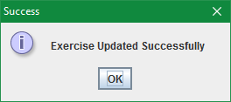

1. To validate that the information has been updated, you can repeat the steps to select the exercise and the form should come up again with the newly updated information

# 12. Trainer: Create Routine

1. Log in as a trainer (username: janed, password: pw), Select the Create Routine Tab

* Input: select create routine
* Output:

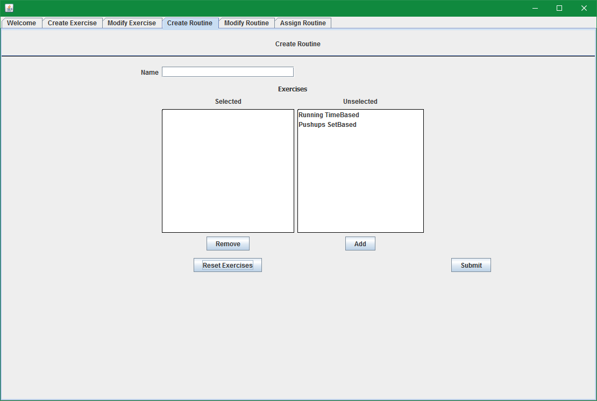

1. Create a routine by selecting exercises and naming the routine

* Input: Set name as "Warmup", add the running exercise, click submit

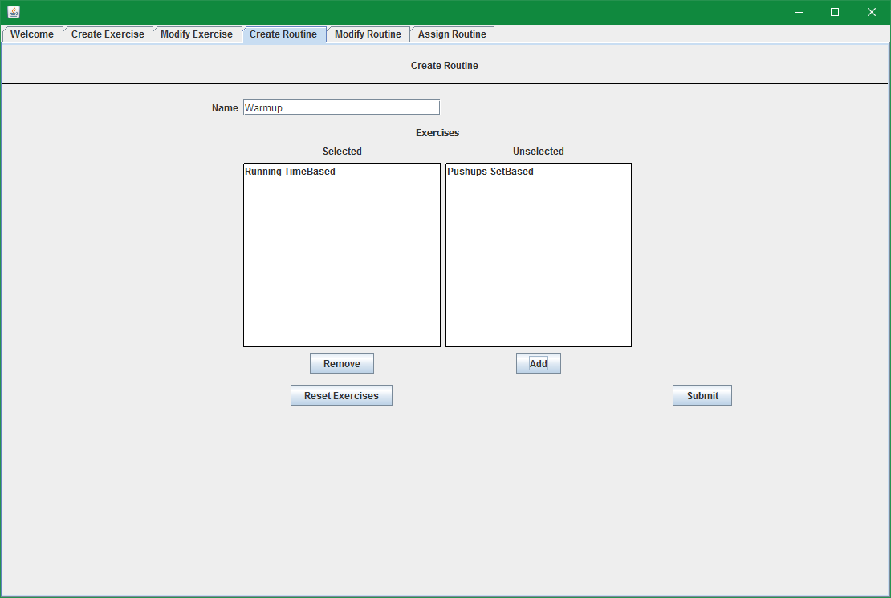

* Output: Success message

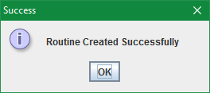

# 13. Trainer: Modify Routine

1. Log in as a Trainer (username: janed, password: pw), select the Modify Routine Tab

* Input: Select to modify routine
* Output:

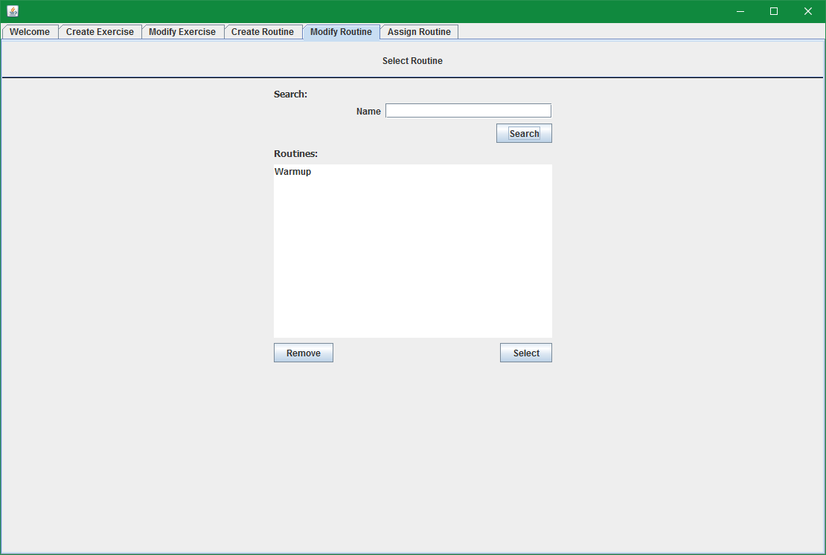

1. Select a routine in the list and click the Select button

* Input: Select the warmup routine and click Select

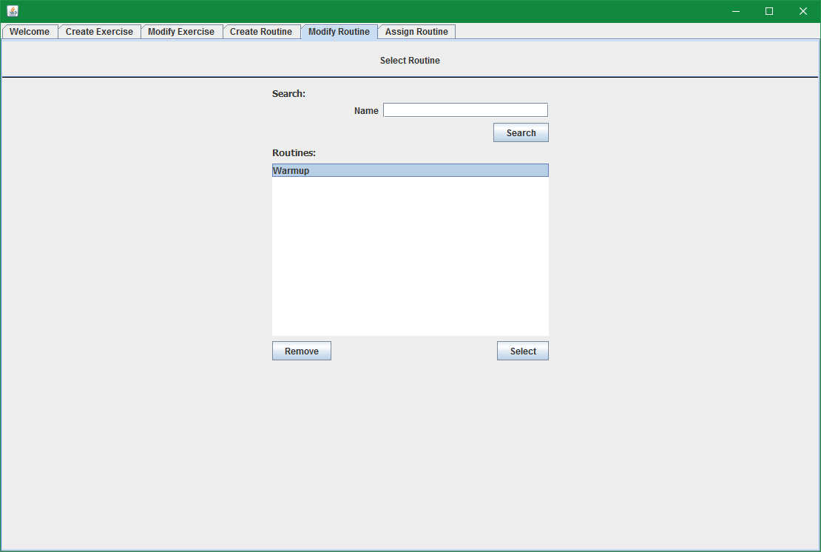

* Output: Modify routine tab with warmup data populated

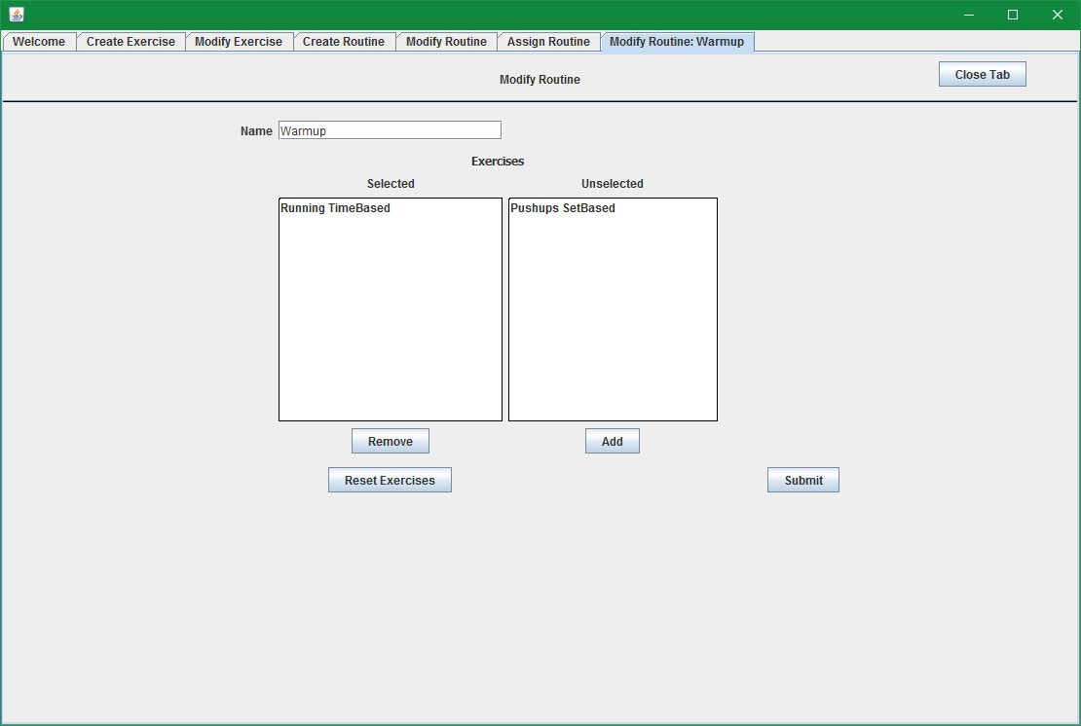

1. Modify the routine by adding pushups to it

* Input: Select Puchups and click add, then click submit

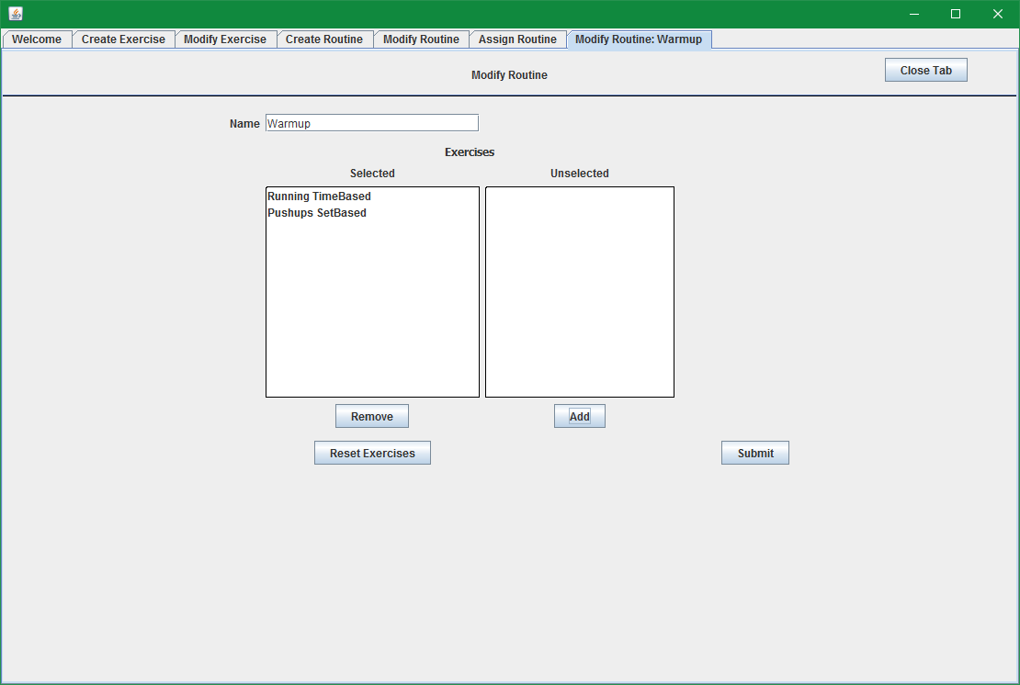

* Output:

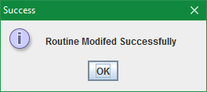

1. To validate that the information has been updated, you can repeat the steps to select the routine and the form should come up again with the newly updated information

# 14. Trainer: Assign Routine

1. Log in as a Trainer (username: janed, password: pw), Select the Assign Routine Tab

* Input: Select assign routine tab
* Output:

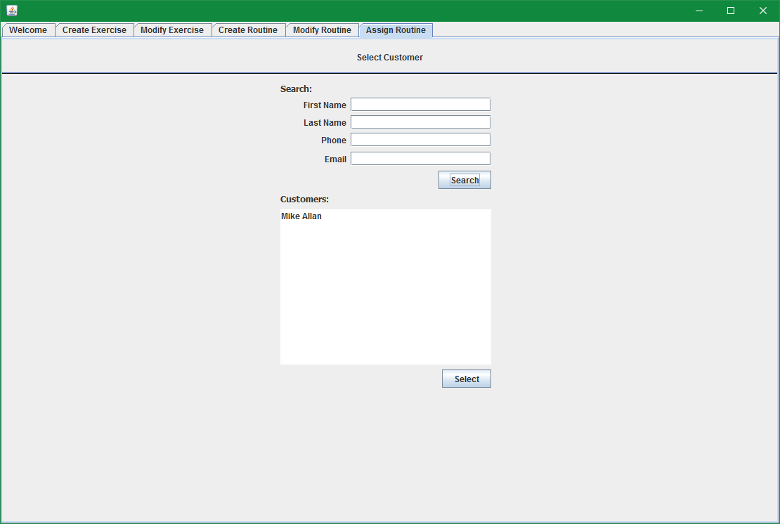

1. Select Mike Allan and click select to assign this customer a routine

* Input: Select Mike Allan in the list and click Select

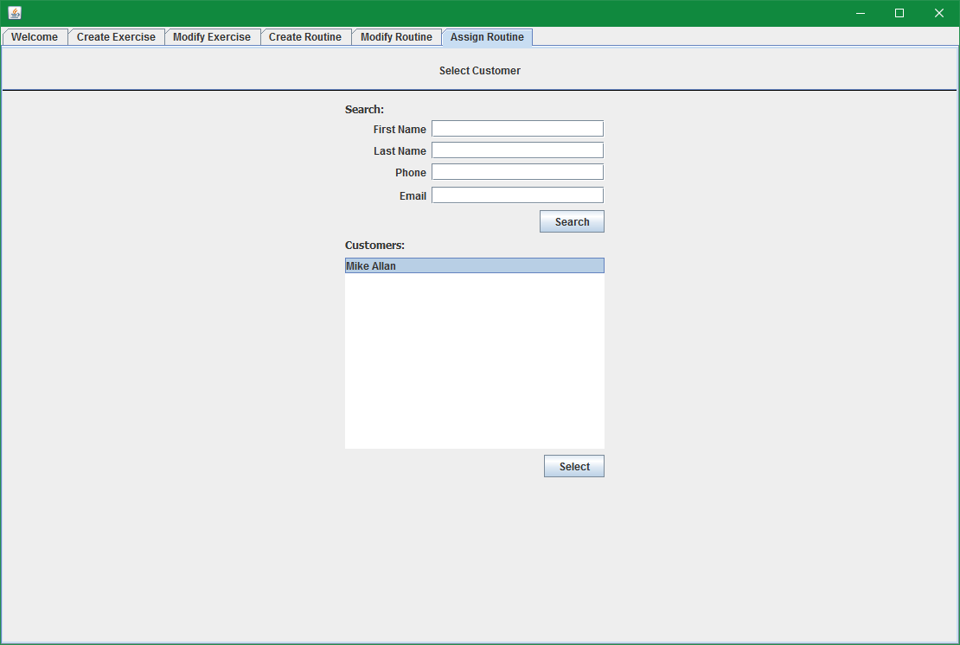

* Output: Assign routine page

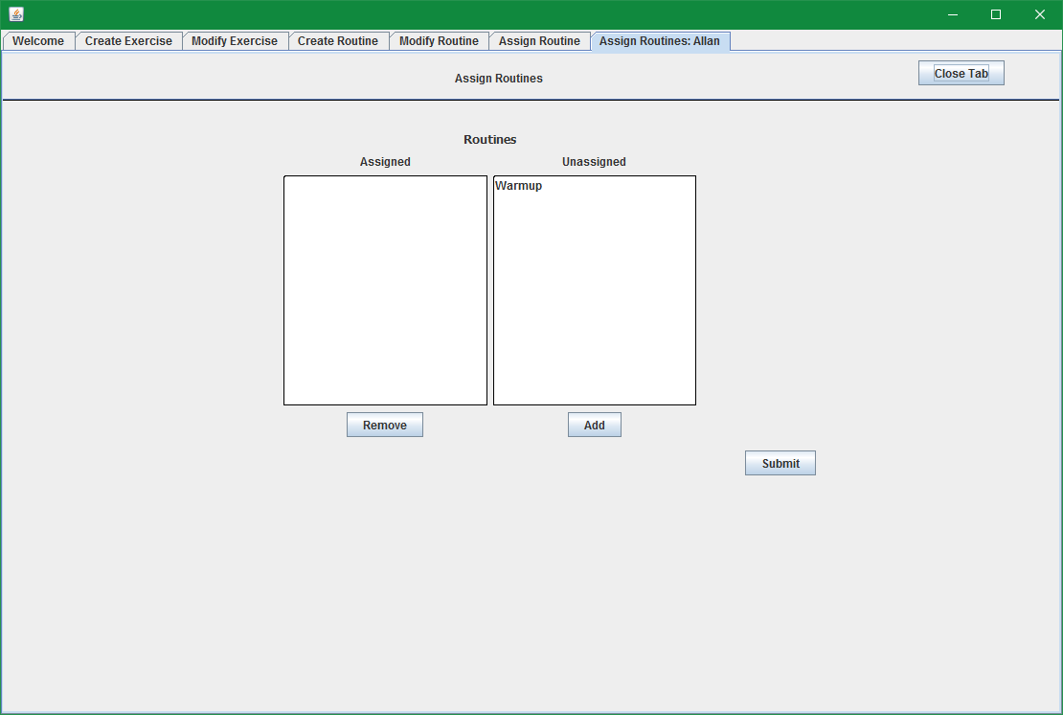

1. Assign the Warmup routine

* Input: Select Warmup, click Add, the routine is now in the assigned column, click submit

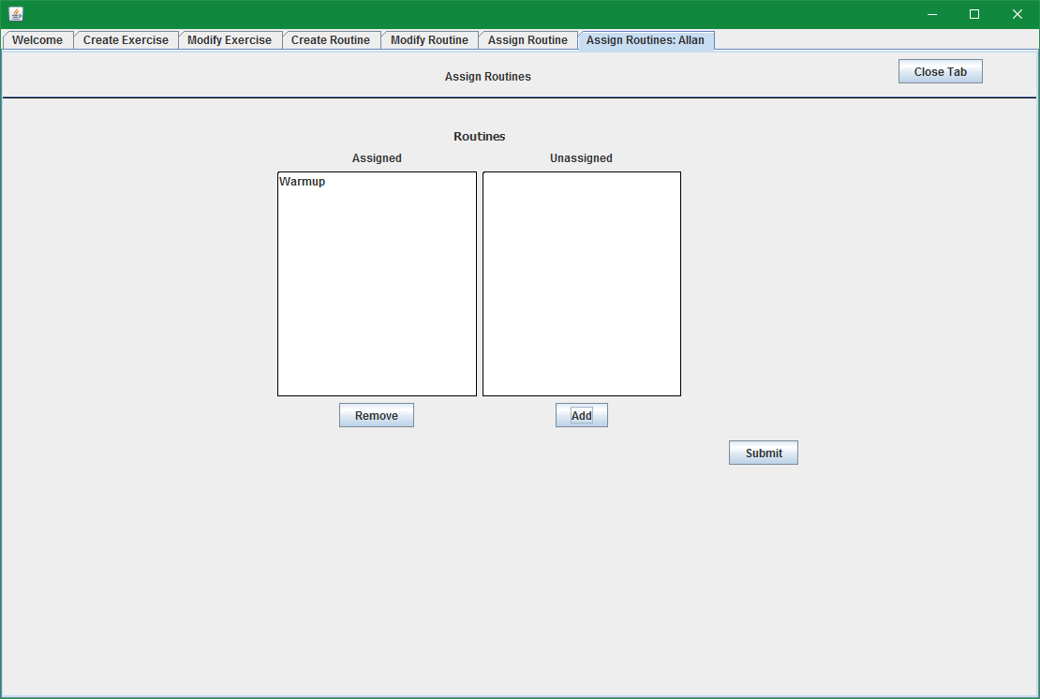

* Output: Success message

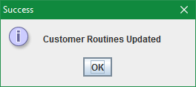

1. To validate the changes to this Customer’s assigned routines have been saved, you can repeat the steps to select the customer and view the assigned and unassigned routine lists.